Prototype Design Pattern

GOF : **Specify the kinds of objects to create using a prototypical instance, and create new objects by copying this prototype.**

# **Structure Diagram**

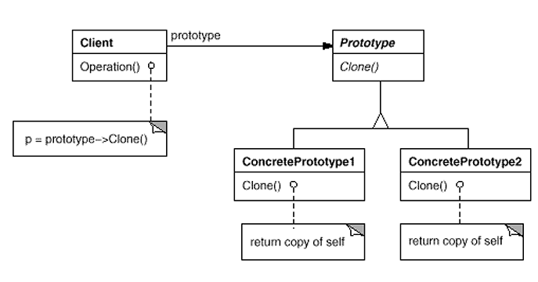

# **Java Code Example**

public interface Prototype {

public abstract Object clone ( );

}

public class ConcretePrototype implements Prototype {

public Object clone() {

return super.clone();

}

}

public class Client {

public static void main( String arg[] ) {

ConcretePrototype obj1= new ConcretePrototype ();

ConcretePrototype obj2 = ConcretePrototype)obj1.clone();

}

}

# **Class Diagram**

